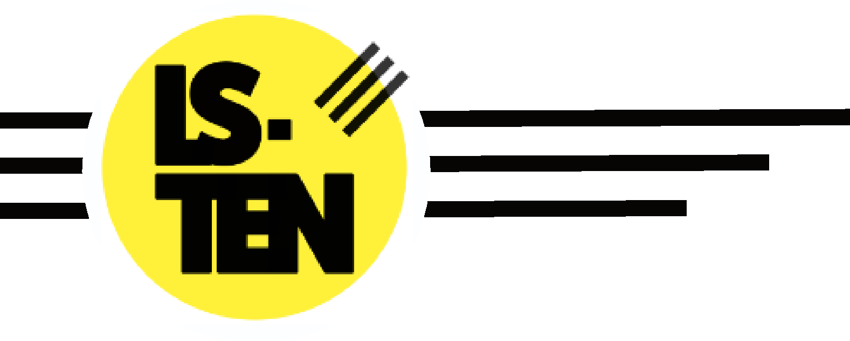

Health and Safety Policy

Issued by: Tosh Wilson (COO, IOSH)
Issue Date: 23/03/2021

Policy Number: HS-001v5

 | Last Review | Review due
Executive: | 14/03/2024 | 14/03/2025
Board:

- POLICY STATEMENT

LS-TEN is committed to maintaining safe and healthy working conditions and to preventing accidents and instances of work-related ill health by ensuring that all activities carried out on company premises or undertaken by its employees are managed in such a manner so as to avoid, reduce or control all foreseeable risks to the health and safety of anyone who may be affected by such activities as far as is reasonably practicable. This policy will be reviewed and revised every 12 months or earlier if there are significant changes to working practices or procedures.

- EMPLOYER'S RESPONSIBILITIES

In furtherance of the above policy statement and the need to ensure compliance with the Health and Safety at Work etc Act 1974 and other relevant health and safety legislation, LS-TEN will:
- provide and maintain safe plant and equipment and safe systems of work.
- ensure materials and substances used are properly stored, handled, used and transported.
- assess the risks to the health and safety of anyone who may be affected by work activities.
- consult with employees on matters affecting their health and safety and ensure that all employees are competent to do their tasks.
- provide information, training, instruction and supervision.
- provide a safe place of employment.
- provide a healthy working environment.
- provide a written Health and Safety Policy.
- look after the health and safety of other people, in addition to employees.
- talk to safety representatives.

3 EMPLOYEES' RESPONSIBILITIES
Employees have a legal responsibility to take care of the health and safety of themselves and others who may be affected by their actions or omissions and to co-operate with supervisors and managers on health and safety issues. Employees should not interfere with anything provided to safeguard their health and safety and should report all health and safety concerns to the appropriate person as set out in this policy.

4 ROLES
4.1 Carl Harrison (CEO) has overall responsibility for health and safety in the workplace and for ensuring that adequate resources are made available to allow the implementation of this policy.
4.2 Jonathan Wilson (Health and Safety Lead) (referred to as Tosh Wilson) has day-to-day responsibility for ensuring that this policy is implemented.

4.3 All supervisors and managers must adequately supervise the work activities of employees and others under their control to ensure that safe systems of work are being followed.

5 RISK ASSESSMENTS
Work activities to be undertaken will be subjected to a health and safety risk assessment prior to the activity starting, in consultation with those who will undertake the work. A separate fire risk assessment will also be undertaken by a "responsible person" who will take reasonable steps to reduce the risk from fire and ensure occupants can safely escape the premises if a fire does occur. A written record of the assessments will be provided identifying any significant hazards and describing the preventative and protective measures required to avoid, eliminate, reduce or control the risks identified to a tolerable level. The control measures must be implemented and adequately maintained and records kept of any monitoring or maintenance of equipment undertaken. The following people have responsibility for the different stages of the health and safety risk assessments and the fire risk assessments:
- Health and Safety Risk Assessments will be undertaken by H and S Lead and the findings will be reported to CEO and recorded in a separate document entitled "Health and Safety Risk Assessments Findings".
- Action required to remove or control health and safety risks will be approved by CEO and Health and Safety Lead will be responsible for ensuring the action required is implemented.
- Jonathan Wilson will check that the implemented actions have removed or reduced the risks. Health and Safety Risk Assessments will be reviewed every 12 months or when significant changes in the work activity occur, whichever is soonest;
- Fire Risk Assessments will be undertaken and implemented by a qualified and competent external assessor, and recorded in a separate document entitled "Fire Risk Assessment which, in addition to identifying hazards and describing preventative measures, will outline an Action Plan.
- Dave Smith (Health and Safety Trustee) will also check that the implemented actions have removed or reduced the risks.
- Assessments will be reviewed every 12 months or when significant changes in the work activity occur, whichever is soonest.

6 SAFE PLANT AND EQUIPMENT
When selecting and purchasing items of plant and equipment it is essential to ensure, as far as possible, that such items are safe and are appropriate for the task and location for which they are intended to be used.
Carl Harrison is responsible for ensuring that any new plant and equipment meets Health and Safety standards before it is purchased. Account must be taken of the persons required to use the items which must be selected to minimise any possible adverse affects to the user and other persons who may be affected. It is also essential to ensure that all plant and equipment is kept safe through regular maintenance and inspection and that all employees are trained to use equipment safely and are aware of instructions provided by manufacturers and suppliers.
Any problems found with plant and equipment should be reported to Jonathan Wilson.
Jonathan Wilson is responsible for identifying all plant and equipment needing maintenance.
Jonathan Wilson is responsible for ensuring effective maintenance procedures are drawn up.
Business Manager is responsible for ensuring that all identified maintenance is implemented.

7 HAZARDOUS SUBSTANCES
Using chemicals or other hazardous substances at work can put people's health at risk. The law requires employers to control exposure to hazardous substances to prevent ill health. The main law on hazardous substances at work is the Control of Substances Hazardous to Health Regulations 2002 ("COSHH"). It defines hazardous substances to include most hazardous chemicals (including waste and by-products), biological agents and any dust. Harmful substances which are covered by COSHH include the vast majority of commercial chemicals, many of which have a warning label. Examples may include bleach and other cleaning agents with a warning label, wood dust, glues and adhesives, solvents, paints, pesticides and chemical fertiliser, medicines and biological agents, oils and fuels, printer/photocopier toner, inks, and paper dust. This list is not exhaustive.

Jonathan Wilson is responsible for identifying all substances that need a COSHH assessment.
Jonathan Wilson is responsible for undertaking COSHH assessments.
Jonathan Wilson is responsible for ensuring that all actions identified in the assessments are implemented.
Jonathan Wilson is responsible for ensuring that all relevant employees are informed of the COSHH assessments.
Jonathan Wilson is responsible for checking that new substances can be used safely before they are purchased.
Assessments will be reviewed every 12 months or when the work activity changes, whichever is soonest.

8 TRAINING
All employees must receive Health and Safety induction training as soon as possible after starting employment and job specific Health and Safety training where work activities require it. Training will also be provided when risks change. Supervisors and managers have a responsibility to identify training needs and to arrange and monitor training of all employees and others under their control. A training needs analysis should be conducted for each job and if this highlights a training requirement then appropriate training must be provided within a reasonable time scale.
Records of all training undertaken by employees will be kept by Amy Harrison.
Amy Harrison, in liaison with the line manager will provide induction training for all employees.
Amy Harrison will arrange job specific training for the following jobs:
- First Aid
- Fire Marshall
- Team Teach

9 REPORTING ACCIDENTS, INVESTIGATING AND MONITORING
9.1 All employees are required to report all accidents and work-related causes of sickness absence to their supervisor or manager. The purpose of reporting such incidents and any subsequent investigation is to identify the underlying cause(s) and any contributing factors and to prevent a recurrence.
Jonathan Wilson is responsible for investigating accidents.
Jonathan Wilson is responsible for investigating work-related causes of sickness absence.
Jonathan Wilson is responsible for acting on investigations.

10 ACCIDENTS AND FIRST AID
10.1 Employers are required by law to have first aid provisions in the workplace and to ensure that there is always a qualified first aider or an "appointed person" present. An appointed person is someone who is authorised, in the absence of a trained first aider, to take charge of the situation if there is a serious injury or illness. They should record all the cases they treat and each record should include at least the name of the patient, date, place, time and circumstances of the accident and details of the injury suffered and treatment given. The records should be kept in a suitable place, and should be readily available. Employers are also required to report certain work-related accidents, dangerous occurrences and diseases.

The appointed person or first aider is Jonathan Wilson.
The first aid boxes are kept in Reception, Education office, Kitchen, medical room and the company vehicle.
All accidents and instances of work-related ill health will be recorded in the accident book which will be kept with the first aid box. Accident forms will be handed to Jonathan Wilson as soon as possible for review.

Jonathan Wilson is responsible for reporting accidents, diseases and dangerous occurrences to the enforcing authority.

11 EMERGENCY PROCEDURES
All employees should read the Fire Action Notices provided in all areas of the workplace which give details of the company's fire and emergency procedures.
Escape routes will be checked every day by Rupert Cowie or Jonathan Wilson.
Fire extinguishers will be maintained and checked every Month by Jonathan Wilson.
Alarms will be tested every week by Jonathan Wilson.
Emergency evacuation will be tested every 6 months.

12 CONSULTATION WITH EMPLOYEES
Employees will be consulted on matters affecting their health and safety by face to face meetings or email.

13 INFORMATION AND SUPERVISION
13.1 Employers must display the health and safety law poster or alternatively, provide employees with individual copies of the same information in a leaflet.
The Health and Safety Law poster is displayed in Reception.
Health and safety advice is available from Jonathan Wilson.

13.2 Employers have an added duty to young people to provide information, instruction, training and supervision. Supervision given to young people must be greatly increased to ensure that they are fully supervised at all times.
Supervision of any young workers or trainees will be undertaken and monitored by Carl Harrison.
13.3 Jonathan Wilson is responsible for ensuring that all employees working at locations under the control of other employers are given relevant health and safety information.

Appendix A – Health & Safety Organisation

CEO
Carl Harrison
Health and Safety Lead
Jonathan Wilson
Head of School  Anita Limbachia |  | Skatepark Manager  Rupert Cowie / |  | Community Manage  Denham Hill & Callum Powell
Education Staff  First Aider |  | Skatepark Staff  First Aider |  | Community Coaches  First Aider

NB - This chart establishes responsibilities and lines of internal communication within the Health & Safety Management System and does not necessarily portray other management structures.

